MINISTRY OF EDUCATION AND SCIENCE OF UKRAINE
NATIONAL TECHNICAL UNIVERSITY
“KHARKIV POLYTECHNIC INSTITUTE”
ННІ КНІТ
REPORT
on laboratory work #7
on the discipline “Programming (C)”

Executed by:
Student of the group КН-925і.е
Sıla Canbolat
Date: 2025-12-28

1. Objective
In this laboratory work I learned how to create unit tests for C code. First I implemented a small function library, afterwards I wrote tests for every function, and after that I generated a coverage report using compiler instrumentation.

2. Variant information
I used Variant 03, so I implemented four expressions (3, 7, 12, 17) as separate library functions.
- E3 = (exp(x) − sin(y)) · z / (cos(w) + tan(v))
- E7 = x/(y + tan(z)) · cos(w) − ln(v + 1)
- E12 = (x − sin(y)) · z² + exp(w)
- E17 = x · (sin(y) − sqrt(z)) + exp(w)

3. Project structure
After I created the project folder, I organized the files into include/src/test folders and added a Makefile.

4. Domain of definition and validation
Before I returned results, I checked the domain restrictions. If the input was invalid, I returned NaN and set ok = 0.
- E3: cos(v) ≠ 0 and cos(w) + tan(v) ≠ 0.
- E7: cos(z) ≠ 0, y + tan(z) ≠ 0, and v + 1 > 0.
- E12: defined for all real inputs.
- E17: z ≥ 0.

5. Unit tests
Afterwards I wrote unit tests using a Unity-style test runner. For each expression I added at least one normal test and one invalid/edge test.

6. Build, run, and coverage
After I finished the code, I built and executed the project with these commands:
- make
- ./build/app
- make test
- make coverage
Figure 1 — Coverage summary (gcov).
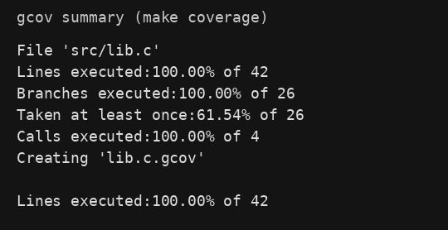

7. Conclusion
In this lab I implemented four mathematical expressions as a reusable C library. After that I verified correctness with unit tests and then I evaluated the test completeness using a coverage report.

References
- Lab instructions (Unit Tests) — provided by the course.
- Visual Studio Code. https://code.visualstudio.com/
- Unity (ThrowTheSwitch). https://github.com/ThrowTheSwitch/Unity
- GCC documentation (gcov). https://gcc.gnu.org/onlinedocs/gcc/Gcov.html

